IT24100033

Sanjana P K D

IT2120 - Probability and Statistics

Lab Sheet 05

1.

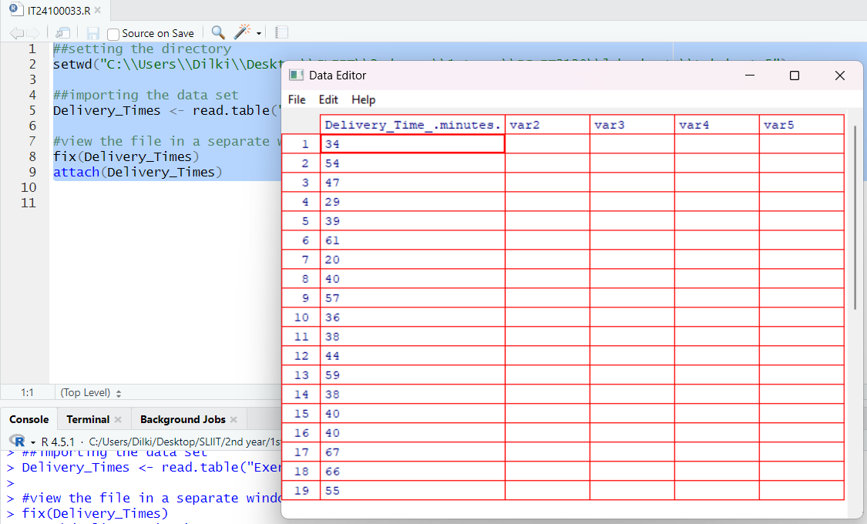

2.

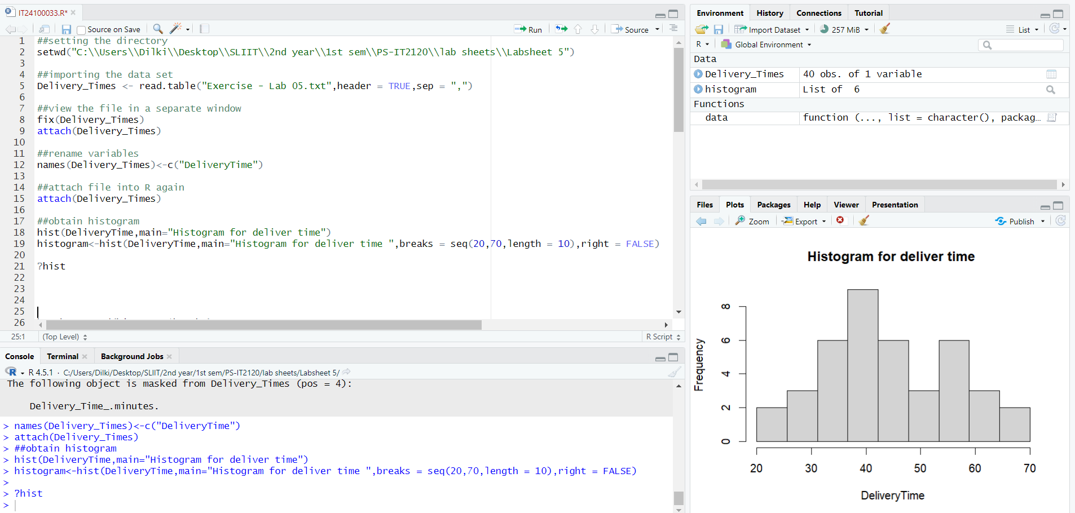3.

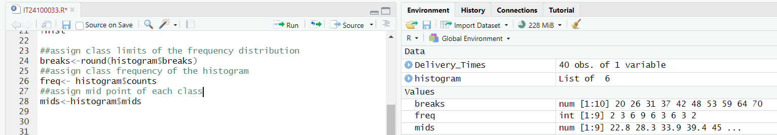

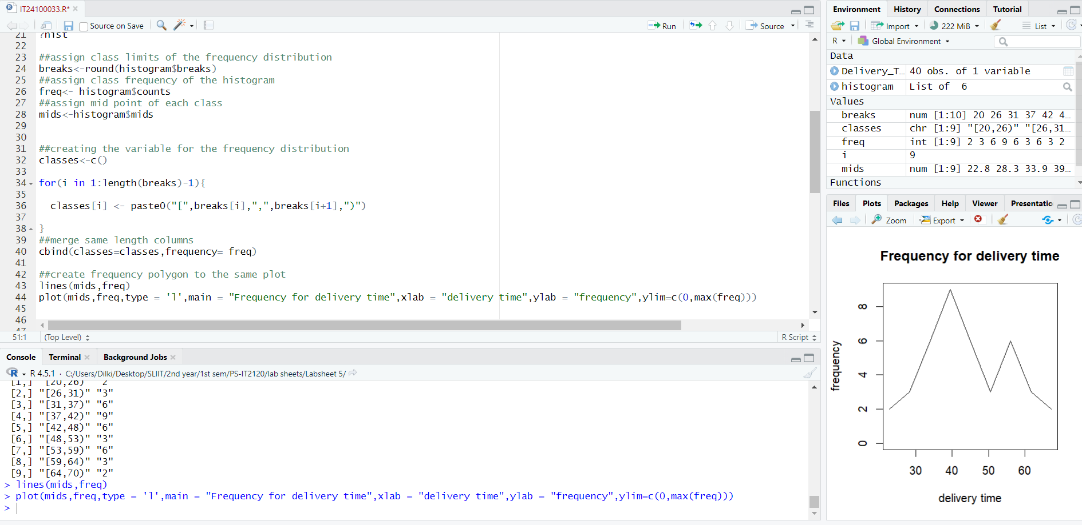

* Unimodal (one main peak around 40).
* Slightly right-skewed (tail extends more to the higher delivery times).

4.

